LED Moving Head Light

User manual

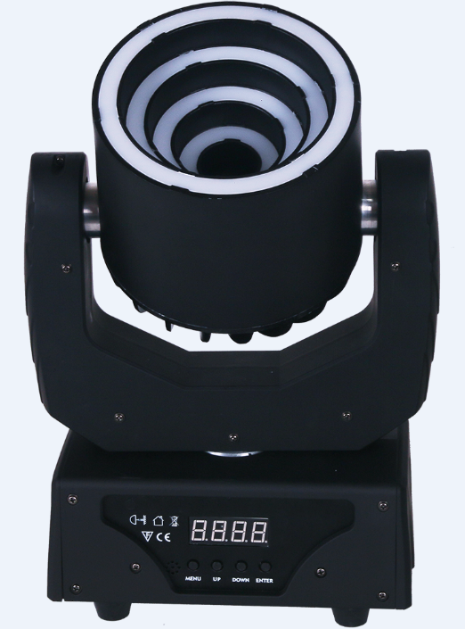

Please keep the manual carefully for further reference

Contents

Introduction &Symbol Instruction ----------------------------------------------------P2

Safety instructions--------------------------------------------------------------------------P3

General Guidelines & Installation -----------------------------------------------------P4

Rigging instruction-------------------------------------------------------------------------P5

Product specification & display operation-----------------------------------------P6

MENU operation -----------------------------------------------------------------------------P7

MENU function setting------------------------------------------------------------------P8-9

DMX channel Instruction -----------------------------------------------------------P10-14

DMX connection and address setting----------------------------------------------P15

Cleaning, maintenance, Warranty card---------------------------------------------P16

Thank you for your patronage. We are confident that our excellent products and service can satisfy you. For your own safety, please read this user manual carefully before installing the device.

In order to install , operate, and maintain the light correctly, we suggest that the installation and operation should be done by the verified technician with following the instruction strictly.

Every person involved with the installation, operation and maintenance of this device has to:
-be qualified
-follow carefully the instructions of this manual
Introduction
Thank you for having chosen this professional moving head. You will see you have acquired a powerful and versatile device. unpack the device. Inside the box you should find:
1. 1PC DMX connection cable
2. 1PC quick lock handle
3. 1PC safety rope
4. 1PC use manual
- 1PC power cable
- 1PC fixture
Please check carefully that there is no damage caused by transportation. please consult your local dealer in case of any problem.

Symbol Instruction On The Device
……………………………………………………………

…

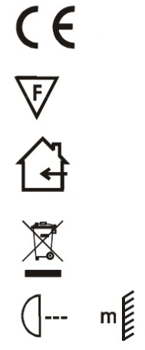
CE Certificate
………

…

……………………………………………………

…

……………………………………………

…

…………………

…

Suitable directly installed on the common combustible materials devices
Only indoor using
Environmental protection
The minimum distance from lighted objects(meter)
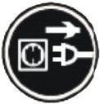
CAUTION!
Keep this device away from rain and moisture!
Unplug mains lead before opening the housing!


CAUTION!

Be careful with your operations. With a wrong voltage you may suffer a dangerous electric shock when touching wires!

Safety Instructions

This device was in perfect condition before leaving factory. In order to maintain this condition and to ensure a safe operation, it is absolutely necessary for the user to follow the safety instructions and warning notes written in this user manual.

Warning!

Damages caused by the disregard of this user manual are not subject to warranty. The dealer will not accept liability for any resulting defects or problems.

►If the device has been exposed to temperature changes due to environmental changes, do not switch it on immediately. The arising condensation could damage the device. Leave the device switched off until it has reached room temperature.
►Please make sure that the device is earthed correctly.
►Please replace housing if it is broken. This fixture can be used after installed.
►The electric connection must be carried out by qualified person.
►Make sure that the available voltage is not higher than the stated voltage in this manual.
►Make sure the power cord is never crimped or damaged by sharp edges. If this happens, replacement of the cable must be done by an authorized dealer.
►If the external flexible cable or cord of this fixture is damaged, it shall be exclusively replaced by the manufacturer or his service agent or a similar qualified person in order to avoid a hazard.
►Please cut off the power before cleaning, maintaining or turn on the fixture.

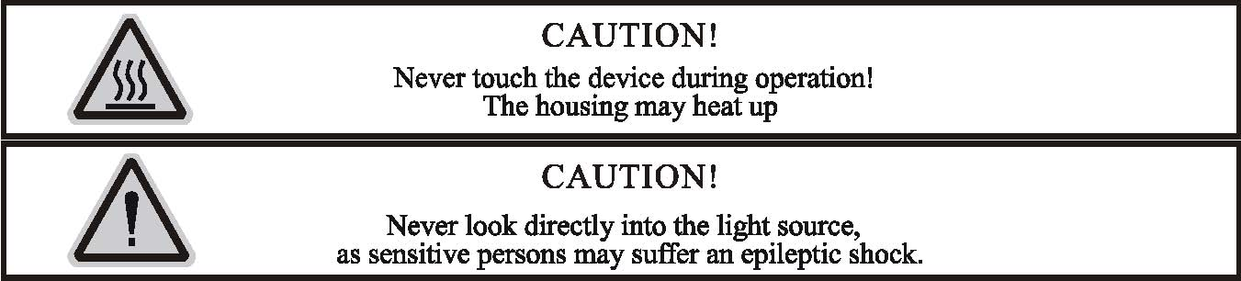

Please be aware that damages caused by manual modifications to the device are not subject to warranty. Keep away from non-professionals.

General Guidelines
►This device is a effect light for professional use on stages, in discotheques, theaters, etc., the device is designed for indoor use only.
►This fixture is only allowed to be operated with the max alternating current which is stated in the technical specifications in the last page of this manual.
►The device can do continuous work for eight hours. Lighting effects are not designed for permanent operation. Consistent operation may shorten the fixture’s lifespan.
►Handle with care, do not make the device by strong shocks.
►While choosing the installation-spot, please make sure that the device is not exposed to extreme heat, moisture or dust. Please don't project the beam onto combustible substances.The minimum distance between light-output from the projector and the illuminated surface must be more than 1 meter.
►Please do not install in damp, overheat or dusty environment or use the device. Do not use light on fuel. The distance between the device and the projectile to keep at least 1 meter.
►If you use the quick lock cam to hang up the fixture, please make sure the quick lock fasteners can be turned in the quick lock holes correctly.
►Operate the device only after having familiarized with its functions. Do not permit unqualified people to operate the device. Most damages are caused by unprofessional operation.
►Please use the original packaging if the device is transported.
►For safety reasons, please be aware that all modifications on the device are forbidden.
►If this device will be operated in any way different to the one described in this manual, the product may suffer damages and the guarantee becomes void. Furthermore, any other operation may lead to short-circuit, burns, electric shock, lamp explosion, crash, etc.

Installation Instruction
CAUTION!
Please consider the GB7000.15/EN60598-2-17 and the other respective national norms during
The installation. The installation must only be carried out by a qualified person.


►The applicable temperature for the lighting is between -10°C to 45°C. Do not use the lighting under or above the temperature.
►Before installation, must ensure installation bracket, handle or truss for this light can hold 10 times of the fixture weight for 1 hour without any harming deformation.
►The installation must always be secured with a secondary safety e.g. an appropriate safety rope.Never stand directly below the device when mounting, removing or servicing the fixture.
►The operator has to make sure the safety relating and machine technical installations are approved
by an expert before taking the device into operation for the first time.
►These installations have to be approved by a skilled person once a year.
►Overhead mounting requires extensive experience, including others calculating working load limits, installation material being used, and periodic safety inspection of all installation material and the device. If you lack these qualifications, do not attempt the installation yourself. Improper installation can result in bodily injury.

Ringing
Mounting Bracket

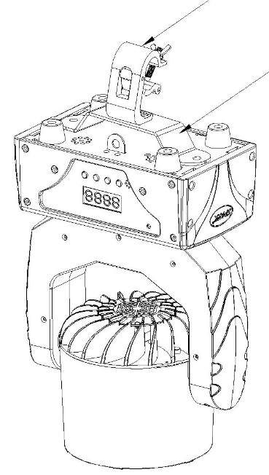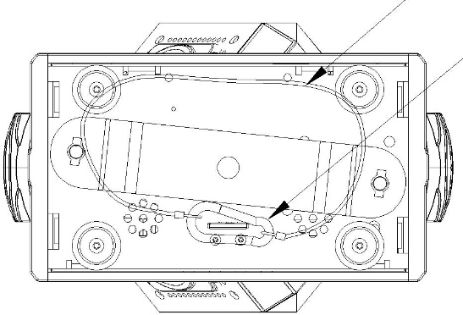
Safety Rope
Rapid locking hook
Handing Bracket

Insert the quick-lock fasteners of the first holder into the respective holes on the bottom of the device.Tighten the quick-lock fasteners fully clockwise.
Make the finished installed mounting bracket tighten on the fixed bracket.
Pull the safety rope through the holes on the bottom of the base and over the trussing system or other safe fixation spot.
Note:This step is quite important to ensure that fixture will not drop out by the damage of clamp.

Product specification
●1PC 30W RGBW 4in1 LED, 88pcs RGB 3in1 SMD5050 LEDs；
●LED average lifetime over 50000 hours, low power consumption
●DMX channel：12/27/29 CH
●Control mode ：master/slave, auto, DMX, sound
●Standard beam angle：6.5º, standard spot angle：13º, (RGBW ) 1000 lum @5M
●Pan: 630º, TILT: 200º+ infinite rotation
● Electrical strobe 1~25Hz；
●Electrical dimming：0%~100%；
●10 built-in programs for auto display or controlled by DMX controller
●can edit program via DMX controller and front display, and save the programs in CPU of the fixture.
● 3Pin DMX connector, LCD display
● Input voltage：AC100 ~240V 50/60Hz， power consumption: 82W

Display

- DMX in
- DMX Out
- ON/OFF
- Fuse
5.Power socket
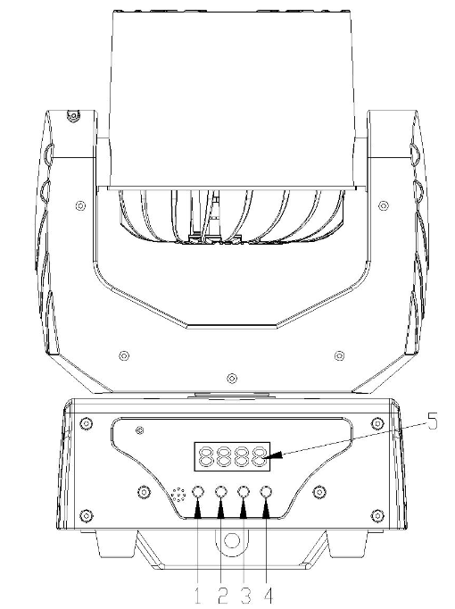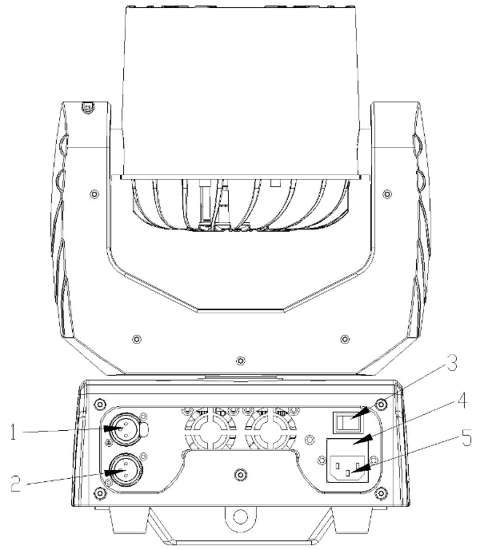
1：（MENU）
2：（UP）
3：（DOWN）
4：（ENTER）
5： Display

Display operation
Nenu（MENU） | MODE | Operation |  | Function | Operation
Nenu（MENU） | Addr (address setting) | press "ENTER" to enter， or press "MENU" to exit | +/- | set address（001-512） | press "ENTER" to save and exit, press MENU to exit only
Nenu（MENU） | Chnd  (channel option) | press "ENTER" to enter， or press "MENU" to exit | +/- | 12Ch | press "ENTER" to save and exit, press MENU to exit only
 |  |  |  | 27Ch | press "ENTER" to save and exit, press MENU to exit only
 |  |  |  | 29Ch | press "ENTER" to save and exit, press MENU to exit only
Nenu（MENU） | Shnd  (show) | press "ENTER" to enter， or press "MENU" to exit | +/- | Sh 1 | press "ENTER" to save and exit, press MENU to exit only
 |  |  |  | Sh 2 | press "ENTER" to save and exit, press MENU to exit only
 |  |  |  | Sh 3 | press "ENTER" to save and exit, press MENU to exit only
Nenu（MENU） | SLnd  (set master/slave unit) | press "ENTER" to enter， or press "MENU" to exit | +/- | Mast (set as master unit) | press "ENTER" to save and exit, press MENU to exit only
 |  |  |  | SL 1(set as slave unit) | press "ENTER" to save and exit, press MENU to exit only
Nenu（MENU） | Lost  (DMX lost mode) | press "ENTER" to enter， or press "MENU" to exit | +/- | hold (hold the last scene when DMX is lost) | press "ENTER" to save and exit, press MENU to exit only
 |  |  |  | soun (enter sound activated mode automatically when DMX is lost) | press "ENTER" to save and exit, press MENU to exit only
 |  |  |  | Auto (enter auto mode automatically when DMX is lost) | press "ENTER" to save and exit, press MENU to exit only
 |  |  |  | blac (keep black when DMX is lost) | press "ENTER" to save and exit, press MENU to exit only
Nenu（MENU） | Sens(sound sensitivity) | press "ENTER" to enter， or press "MENU" to exit |  | S000-S099 (sound sensitivity) | press "ENTER" to save and exit, press MENU to exit only
Nenu（MENU） | Angl (angle) | press "ENTER" to enter， or press "MENU" to exit | +/- | 630 | press "ENTER" to save and exit, press MENU to exit only
 |  |  |  | 540 | press "ENTER" to save and exit, press MENU to exit only
Nenu（MENU） | Pint (PAN reverse) | press "ENTER" to enter， or press "MENU" to exit | +/- | yes | press "ENTER" to save and exit, press MENU to exit only
 |  |  |  | no | press "ENTER" to save and exit, press MENU to exit only
Nenu（MENU） | Tint (TILT reverse) | press "ENTER" to enter， or press "MENU" to exit | +/- | yes | press "ENTER" to save and exit, press MENU to exit only
 |  |  |  | no | press "ENTER" to save and exit, press MENU to exit only
Nenu（MENU） | Padj (Pan fine) | press "ENTER" to enter， or press "MENU" to exit | +/- | P000-P255 (PAN fine) | press "ENTER" to save and exit, press MENU to exit only
Nenu（MENU） | Tadj (TILT fine) | press "ENTER" to enter， or press "MENU" to exit | +/- | T000-T255 (TILT fine) | press "ENTER" to save and exit, press MENU to exit only
Nenu（MENU） | Led  (LED display backlight set) | press "ENTER" to enter， or press "MENU" to exit |  | on (LED display backlight ON) | press "ENTER" to save and exit, press MENU to exit only
 |  |  |  | off (display reverse OFF) | press "ENTER" to save and exit, press MENU to exit only
Nenu（MENU） | disp (display reverse) | press "ENTER" to enter， or press "MENU" to exit |  | on (display reverse ON) | press "ENTER" to save and exit, press MENU to exit only
 |  |  |  | off (display reverse OFF) | press "ENTER" to save and exit, press MENU to exit only
Nenu（MENU） | Fhrs (working hours) | press "ENTER" to enter， or press "MENU" to exit |  | display working hours | press "ENTER" to save and exit, press MENU to exit only
Nenu（MENU） | Ver （software version) | press "ENTER" to enter， or press "MENU" to exit |  | current software version | press "ENTER" to save and exit, press MENU to exit only
Nenu（MENU） | Rest (all reset) | press "ENTER" to enter， or press "MENU" to exit |  | all reset | press "ENTER" to save and exit, press MENU to exit only
Nenu（MENU） | defa (reset to factory defaults) | press "ENTER" to enter， or press "MENU" to exit |  | reset to defaults | press "ENTER" to save and exit, press MENU to exit only

MENU operation
This fixture has 4 keys on front panel for operation, press these keys to set DMX address, reset, edit and run programs and so on.

[MENU]: press MENU key to enter edit status, in edit status, if press MENU again, it will return the upper interface. If no operation 30 seconds after enter edit status, the fixture will exit the edit status automatically.

[Up]: press UP key, the indicator will flash, the address increases one by one, if hold the key continuously, the address will increase rapidly. If no press within 30 seconds, the indicator stops flashing and exit it. In edit status, press UP key, it will display the options circularly from down to up.

[Down]：press DOWN key, the indicator will flash, the address decreases one by one, if hold the key continuously, the address will decrease rapidly. If no press within 30 seconds, the indicator stops flashing and exit it. In edit status, press DOWN key, it will display the options circularly from up to down.

[ENTER]：in normal status, no function after press ENTER. In edit mode, press ENTER to enter lower interface.

MENU Function setting
1）DMX address setting
1.Press <MENU >to enter EDIT interface
2. Press <UP/DOWN> to choose, then press <ENTER> to enter【Addr】
3. Press <Up/Down> to choose address 001~XXX
4. Press <ENTER> to confirm, or press "MENU" to exit
2）Channel mode Setting
1. Press <MENU> to enter EDIT interface
2. Press <UP/DOWN> to choose, then press ENTER to enter 【Chnd】
3. Press UP/DOWN to choose each channel.‘12CH’/‘27CH’/‘29CH’
4. Press ENTER to confirm, or press "MENU" to exit
3) Sound activated show mode Setting(before this setting, please Press MENU into < Lost> to select <Soun> or <Auto>and save, user should be in Sound/Auto Mode first, the different scene can be selected)
1. Press <MENU> to enter EDIT interface
2. Press< UP/DOWN> to choose, then press ENTER to enter 【Shnd】
3. Press< UP/DOWN> to choose light’s three shows:Sh1,Sh2,Sh3 (can choose any show mode which is activated by sound)
4. Press <Enter> to confirm, or press "MENU" to exit.
4）Master-slave setting
1. Press <MENU> to enter EDIT interface
2. Press <UP/DOWN> to choose, then press ENTER to enter 【SLnd】
3. Press <UP/DOWN> to choose Mast/SL1.
4. Press <Enter> to confirm, or press "MENU" to exit.
5）DMX Lost Setting
1. Press< MENU> to enter EDIT interface
2. Press <UP/DOWN >to choose, then press ENTER to enter 【Lost】
3.press< UP/DOWN> can choose light’s 4 scenes:hold,soun, Auto,blac
(can choose any scene mode to operate )
4. Press <Enter> to confirm, or press "MENU" to exit.
6）Sound sensitivity Setting (before this setting, please Press MENU into < Lost> to select <Soun> and save, user should be in Sound Mode first)
1. Press MENU to enter EDIT interface
2. Press UP/DOWN to choose, then press ENTER to enter 【Sens】
3. Press <Up/Down>, <Enter> to adjust the sound sensitivity from 0%-99%.
4. Press <Enter> to confirm, or press "MENU" to exit.
7) Pan angle setting
1. Press<MENU> to enter EDIT interface.
2. Press UP/DOWN to choose, then press ENTER to enter 【Angl】
3 Press<Up/Down> to choose ‘630’，/‘540’
4. Press <Enter> to confirm, or press "MENU" to exit.
8) Pan reverse setting
1. Press<MENU> to enter EDIT interface.
2. Press UP/DOWN to choose, then press ENTER to enter 【Pint】
3. Press<Up/Down> to choose ‘YES’，/‘NO’
4. Press <Enter> to confirm, or press "MENU" to exit.
9) Tilt reverse setting
1. Press<MENU> to enter EDIT interface.
2. Press UP/DOWN to choose, then press ENTER to enter 【Tint】
3 Press<Up/Down> to choose ‘YES’，/‘NO’
4. Press <Enter> to confirm,or press "MENU" to exit.
10) Pan fine setting
1. Press<MENU> to enter EDIT interface.
2. Press UP/DOWN to choose, then press ENTER to enter 【Padj】
3 Press<Up/Down> to choose ‘P000-P255”’
- Press <Enter> to confirm,or press "MENU" to exit.
11) TILT fine setting
1. Press<MENU> to enter EDIT interface.
2. Press UP/DOWN to choose, then press ENTER to enter 【Tadj】
3 Press<Up/Down> to choose ‘T000-T255”’
4. Press <Enter> to confirm,or press "MENU" to exit.
12）LED back light setting
1. Press MENU to enter EDIT interface.
2. Press UP/DOWN to choose, then press ENTER to enter 【LED 】
3. Press<Up/Down> to choose ‘ON’，/‘OFF’
4. Press <Enter> to confirm, or press "MENU" to exit.
13) Display reverse setting
1. Press MENU to enter EDIT interface.
2 .Press UP/DOWN to choose, then press ENTER to enter 【Disp】
3. Press<Up/Down> to choose ‘ON’，/‘OFF’
4. Press <Enter> to confirm, or press "MENU" to exit.
14) Working time
1. Press < ENTER> to enter EDIT interface
2.Press < UP/DOWN>, then press < ENTER> 【Fhrs】to check the light’s working time
3.Press <Enter> to confirm, or press "MENU" to exit.
15）Software Version
1. Press < ENTER> to enter EDIT interface
2. Press < UP/DOWN>, then press < ENTER> 【Ver】to check the light’s version information
3.Press <Enter> to confirm, or press "MENU" to exit.
16）Whole fixture reset
1. Press< MENU> to enter EDIT interface.
2. Press UP/DOWN to choose, then press ENTER to enter 【Rest】
3. After reset, it will go back to the upper interface
17）Factory default settings
1. Press MENU to enter EDIT interface.
2. Press UP/DOWN to choose, then press ENTER to enter 【Defa】
3. Press<Enter> to confirm,or press "MENU" to exit.

DMX Channel Instruction

12 DMX Channel chart
Channel | Function | Value | Details
CH1 | PAN | 000-255 | Pan 0-630°
CH2 | Tilt | 000-255 | Tilt 0-210°
CH3 | Speed | 000-255 | Pan/Tilt from fast to slow
CH4 | Red dimmer | 000-255 | 60W LED Red dimmer (0-100%)
CH5 | Green dimmer | 000-255 | 60W LED Green dimmer (0-100%)
CH6 | Blue dimmer | 000-255 | 60W LED Blue dimmer (0-100%)
CH7 | White dimmer | 000-255 | 60W LED White dimmer (0-100%)
CH8 | 60W LED Strobe | 000-015 | no strobe
CH8 | 60W LED Strobe | 016-095 | Strobe （1HZ-25HZ Slow-Fast）
CH8 | 60W LED Strobe | 096-175 | Strobe （1HZ Slow-Fast）
CH8 | 60W LED Strobe | 176-255 | Random Strobe
CH9 | Dimmer | 000-255 | Master Dimmer 0-100%
CH10 | SMD ring auto program | 000-035 | no function
CH10 | SMD ring auto program | 036-040 | Red
CH10 | SMD ring auto program | 041-045 | Green
CH10 | SMD ring auto program | 046-050 | Blue
CH10 | SMD ring auto program | 051-055 | R&G
CH10 | SMD ring auto program | 056-060 | R&B
CH10 | SMD ring auto program | 061-065 | G&B
CH10 | SMD ring auto program | 066-070 | R&G&B
CH10 | SMD ring auto program | 071-080 | RGB fading
CH10 | SMD ring auto program | 081-085 | Red-Chase
CH10 | SMD ring auto program | 086-090 | Green-Chase
CH10 | SMD ring auto program | 091-095 | Blue-Chase
CH10 | SMD ring auto program | 096-100 | R&G-Chase
CH10 | SMD ring auto program | 101-105 | R&B-Chase
CH10 | SMD ring auto program | 106-110 | G&B-Chase
CH10 | SMD ring auto program | 111-115 | R&G&B-Chase
CH10 | SMD ring auto program | 116-120 | red ring zoom out
CH10 | SMD ring auto program | 121-125 | green ring zoom out
CH10 | SMD ring auto program | 126-130 | blue ring zoom out
CH10 | SMD ring auto program | 131-135 | R/G/B/W ring zoom out
CH10 | SMD ring auto program | 136-140 | red ring zoom in
CH10 | SMD ring auto program | 141-145 | green ring zoom in
CH10 | SMD ring auto program | 146-150 | blue ring zoom in
CH10 | SMD ring auto program | 151-155 | R/G/B/W ring zoom in
CH10 | SMD ring auto program | 156-160 | effect switch between R/G/B/W
CH10 | SMD ring auto program | 161-165 | effect switch between yellow/purple/cyan/white
CH10 | SMD ring auto program | 166-255 | color flowing in ring 1-4, 9 effects in total,  each 10 digits for 1 effect
CH11 | SMD ring speed | 000-255 | Slow-Fast
CH12 | Rest | 000-49 | No Function
CH12 | Rest | 050-099 | auto program 1
CH12 | Rest | 100-149 | auto program 2
CH12 | Rest | 149-199 | auto program 3
CH12 | Rest | 200-249 | sound activated program
CH12 | Rest | 250-255 | All Reset

27 DMX Channel chart
CH | Function | Value | details
CH1 | PAN | 000-255 | Pan 0-630°
CH2 | Tilt | 000-255 | Tilt 0-210°
CH3 | Pan/Tilt Speed | 000-255 | Pan/Tilt speed from fast to slow
CH4 | Red | 000-255 | Red(0-100%)
CH5 | Green | 000-255 | Green(0-100%)
CH6 | Blue | 000-255 | Blue(0-100%)
CH7 | White | 000-255 | White(0-100%)
CH8 | 60W LED Strobe | 000-015 | no strobe
CH8 | 60W LED Strobe | 016-095 | Strobe （1HZ-25HZ from slow to fast）
CH8 | 60W LED Strobe | 096-175 | Strobe （1HZ from slow to fast）
CH8 | 60W LED Strobe | 176-255 | Random Strobe
CH9 | 60W LED master dimmer | 000-255 | Master Dimmer 0-100%
CH10 | SMD ring 1's red dimmer | 000-255 | Red1(0-100%)
CH11 | SMD ring 1's green dimmer | 000-255 | Green1(0-100%)
CH12 | SMD ring 1's blue dimmer | 000-255 | Blue1(0-100%)
CH13 | SMD ring 2's red dimmer | 000-255 | Red2(0-100%)
CH14 | SMD ring 2's green dimmer | 000-255 | Green2(0-100%)
CH15 | SMD ring 2's blue dimmer | 000-255 | Blue2(0-100%)
CH16 | SMD ring 3's red dimmer | 000-255 | Red3(0-100%)
CH17 | SMD ring 3's green dimmer | 000-255 | Green3(0-100%)
CH18 | SMD ring 3's blue dimmer | 000-255 | Blue3(0-100%)
CH19 | SMD ring 4's red dimmer | 000-255 | Red4(0-100%)
CH20 | SMD ring 4's green dimmer | 000-255 | Green4(0-100%)
CH21 | SMD ring 4's blue dimmer | 000-255 | Blue4(0-100%)
CH22 | SMD ring strobe | 000-029 | SMD ring strobe OFF
CH22 | SMD ring strobe | 030-225 | SMD ring strobe ON, speed from slow to fast
CH22 | SMD ring strobe | 226-255 | SMD ring strobe OFF
CH23 | SMD ring master dimmer | 000-255 | SMD ring master dimmer 0-100%
CH24 | SMD ring auto program | 000-035 | no function
CH24 | SMD ring auto program | 036-040 | Red
CH24 | SMD ring auto program | 041-045 | Green
CH24 | SMD ring auto program | 046-050 | Blue
CH24 | SMD ring auto program | 051-055 | R&G
CH24 | SMD ring auto program | 056-060 | R&B
CH24 | SMD ring auto program | 061-065 | G&B
CH24 | SMD ring auto program | 066-070 | R&G&B
CH24 | SMD ring auto program | 071-080 | RGB fading
CH24 | SMD ring auto program | 081-085 | Red-Chase
CH24 | SMD ring auto program | 086-090 | Green-Chase
CH24 | SMD ring auto program | 091-095 | Blue-Chase
CH24 | SMD ring auto program | 096-100 | R&G-Chase
CH24 | SMD ring auto program | 101-105 | R&B-Chase
CH24 | SMD ring auto program | 106-110 | G&B-Chase
CH24 | SMD ring auto program | 111-115 | R&G&B-Chase
CH24 | SMD ring auto program | 116-120 | red ring zoom out
CH24 | SMD ring auto program | 121-125 | green ring zoom out
CH24 | SMD ring auto program | 126-130 | blue ring zoom out
CH24 | SMD ring auto program | 131-135 | R/G/B/W ring zoom out
CH24 | SMD ring auto program | 136-140 | red ring zoom in
CH24 | SMD ring auto program | 141-145 | green ring zoom in
CH24 | SMD ring auto program | 146-150 | blue ring zoom in
CH24 | SMD ring auto program | 151-155 | R/G/B/W ring zoom in
CH24 | SMD ring auto program | 156-160 | effect switch between R/G/B/W
CH24 | SMD ring auto program | 161-165 | effect switch between yellow/purple/cyan/white
CH24 | SMD ring auto program | 166-255 | color flowing in ring 1-4, 9 effects in total,  each 10 digitals for 1 effect
CH25 | SMD ring speed | 000-255 | Slow-Fast
CH26 | Colour Macro | 000-045 | No Function
CH26 | Colour Macro | 046-065 | Red
CH26 | Colour Macro | 066-085 | Green
CH26 | Colour Macro | 086-105 | Blue
CH26 | Colour Macro | 106-125 | White
CH26 | Colour Macro | 126-145 | R&G
CH26 | Colour Macro | 146-165 | R&B
CH26 | Colour Macro | 166-185 | G&B
CH26 | Colour Macro | 186-205 | R&G&B&W
CH26 | Colour Macro | 206-255 | RGB fading from fast to slow
CH27 | Rest | 000-49 | No Function
CH27 | Rest | 050-099 | auto program 1
CH27 | Rest | 100-149 | auto program 2
CH27 | Rest | 149-199 | auto program 3
CH27 | Rest | 200-249 | sound activated program
CH27 | Rest | 250-255 | All Reset

29 DMX Channel chart
CH | Function | Value | Details
CH1 | PAN | 000-255 | Pan 0-630°
CH2 | PAN Fine | 000-255 | Pan fine
CH3 | Tilt | 000-255 | Tilt 0-210°
CH4 | Tilt Fine | 000-255 | Tilt Fine
CH5 | PAN/TILT Speed | 000-255 | Pan/Tilt speed from fast to slow
CH6 | Red | 000-255 | Red dimming (0-100%)
CH7 | Green | 000-255 | Green dimming (0-100%)
CH8 | Blue | 000-255 | Blue dimming (0-100%)
CH9 | White | 000-255 | White dimming (0-100%)
CH10 | Strobe | 000-015 | no strobe
CH10 | Strobe | 016-095 | Strobe （1HZ-25HZ from slow to fast）
CH10 | Strobe | 096-175 | Strobe （1HZ from slow to fast）
CH10 | Strobe | 176-255 | Random Strobe
CH11 | master dimmer | 000-255 | Master Dimmer 0-100%
CH12 | SMD ring 1's red dimmer | 000-255 | Red1(0-100%)
CH13 | SMD ring 1's green dimmer | 000-255 | Green1(0-100%)
CH14 | SMD ring 1's blue dimmer | 000-255 | Blue1(0-100%)
CH15 | SMD ring 2's red dimmer | 000-255 | Red2(0-100%)
CH16 | SMD ring 2's green dimmer | 000-255 | Green2(0-100%)
CH17 | SMD ring 2's blue dimmer | 000-255 | Blue2(0-100%)
CH18 | SMD ring 3's red dimmer | 000-255 | Red3(0-100%)
CH19 | SMD ring 3's green dimmer | 000-255 | Green3(0-100%)
CH20 | SMD ring 3's blue dimmer | 000-255 | Blue3(0-100%)
CH21 | SMD ring 4's red dimmer | 000-255 | Red4(0-100%)
CH22 | SMD ring 4's green dimmer | 000-255 | Green4(0-100%)
CH23 | SMD ring 4's blue dimmer | 000-255 | Blue4(0-100%)
CH24 | SMD ring strobe | 000-029 | SMD ring strobe OFF
CH24 | SMD ring strobe | 030-225 | SMD ring strobe ON, speed from slow to fast
CH24 | SMD ring strobe | 226-255 | SMD ring strobe OFF
CH25 | SMD ring master dimmer | 000-255 | SMD ring master dimmer 0-100%
CH26 | SMD ring auto program | 000-035 | no function
CH26 | SMD ring auto program | 036-040 | Red
CH26 | SMD ring auto program | 041-045 | Green
CH26 | SMD ring auto program | 046-050 | Blue
CH26 | SMD ring auto program | 051-055 | R&G
CH26 | SMD ring auto program | 056-060 | R&B
CH26 | SMD ring auto program | 061-065 | G&B
CH26 | SMD ring auto program | 066-070 | R&G&B
CH26 | SMD ring auto program | 071-080 | RGB fading
CH26 | SMD ring auto program | 081-085 | Red-Chase
CH26 | SMD ring auto program | 086-090 | Green-Chase
CH26 | SMD ring auto program | 091-095 | Blue-Chase
CH26 | SMD ring auto program | 096-100 | R&G-Chase
CH26 | SMD ring auto program | 101-105 | R&B-Chase
CH26 | SMD ring auto program | 106-110 | G&B-Chase
CH26 | SMD ring auto program | 111-115 | R&G&B-Chase
CH26 | SMD ring auto program | 116-120 | red ring zoom out
CH26 | SMD ring auto program | 121-125 | green ring zoom out
CH26 | SMD ring auto program | 126-130 | blue ring zoom out
CH26 | SMD ring auto program | 131-135 | R/G/B/W ring zoom out
CH26 | SMD ring auto program | 136-140 | red ring zoom in
CH26 | SMD ring auto program | 141-145 | green ring zoom in
CH26 | SMD ring auto program | 146-150 | blue ring zoom in
CH26 | SMD ring auto program | 151-155 | R/G/B/W ring zoom in
CH26 | SMD ring auto program | 156-160 | effect switch between R/G/B/W
CH26 | SMD ring auto program | 161-165 | effect switch between yellow/purple/cyan/white
CH26 | SMD ring auto program | 166-255 | color flowing in ring 1-4, 9 effects in total, each 10 digits for 1 effect
CH27 | SMD ring speed | 000-255 | Slow-Fast
CH28 | Colour Macro | 000-045 | No Function
CH28 | Colour Macro | 046-065 | Red
CH28 | Colour Macro | 066-085 | Green
CH28 | Colour Macro | 086-105 | Blue
CH28 | Colour Macro | 106-125 | White
CH28 | Colour Macro | 126-145 | R&G
CH28 | Colour Macro | 146-165 | R&B
CH28 | Colour Macro | 166-185 | G&B
CH28 | Colour Macro | 186-205 | R&G&B&W
CH28 | Colour Macro | 206-255 | RGB fading from fast to slow
CH29 | Rest | 000-49 | No Function
CH29 | Rest | 050-099 | auto program 1
CH29 | Rest | 100-149 | auto program 2
CH29 | Rest | 149-199 | auto program 3
CH29 | Rest | 200-249 | sound activated program
CH29 | Rest | 250-255 | All Reset

DMX-512 connection

Connect the provided XLR cable to the male 3-pin XLR output of your controller and the other side to the female 3-pin XLR input of the light.You can chain multiple lights together through serial linking

The cable needed should be two core, screened cable with XLR input and output connectors. Please refer to the diagram below.
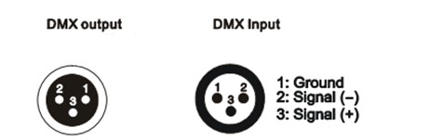
XLR Mounting socket
XLR Mounting plug
DMX address setting
Each fixture must have a specific starting address. When receiving signal transmission, fixture will receive channel control signals from DMX controller through this starting address.
According to different requirements or easy to use, the user can set many fixtures to the same address, also can set up a separately address for every device.
If more than one fixtures have the same address, all of them receive the same DMX channel signal from DMX controller. All connected fixtures are jointly controlled, DMX controller can't control a device separately.
If each device has a different address, each device will be separate and accept separate DMX512 control signal through the separate DMX address, so that more convenient to control one device separately. this method must be based on channel quantity of device to determine a starting address.

This device has 29 channels, so the first device starting address set 1, second is 30(1+29), third is 45(30+29)) and so on.
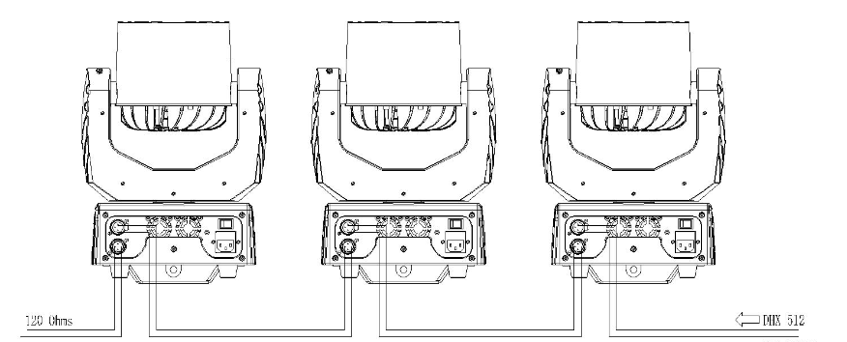
Address 59
Address 30
Address 01

Cleaning and maintenance

Cleaning should be performed in every 15-day, by using a sponge which is dipped with alcohol, rather than wet cloth or other chemical liquid, to clean the mirror.
Turn off power before cleaning and maintenance!
CAUTION

Attention
Do not look into light source directly when turn on the light, and make sure power off before do any installation or maintenance.

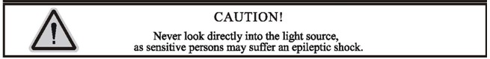
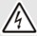 Wires connection must be done by professional person!
CAUTION

Warranty Card

We will provide 1 year warranty under the condition that user has operated the light normally and lifetime service. We won't provide warranty if the damage is caused by artificial or force majeure event. Cost of fittings should be charged by user if product needs maintenance after 1 year .Please cut this warranty card and shipped it along with the product to our factory when applying for warranty.
Product： Purchasing date： Code of invoice：
Warranty date: From To
User’s name： Add：
Company： Tel：

